Worksheet: sewing a dress in the workshop in Sinop under the theme Sea Breeze
Materials and tools: facric , scissors ,neddles,sewing machine, fishing net fabric
Instructions
For the pelerine
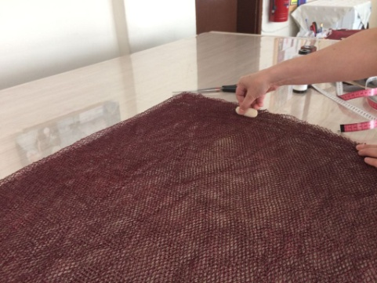
1) Marking the hood and arm holes on the fishing net fabric

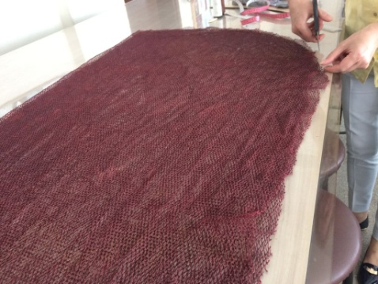
2) Cutting the pelerine as it is measured.
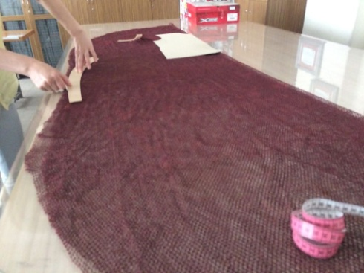
3) Clearing up the arm holes.

For the top
Instructions:
- Sewing the coupes.
- Preparing and fixing the loops up.
- Combining the side seams.
- Sewing the interlining.
- Preparing 3 shoulder straps and fixing them to the top.
- Placing the star figure.
- Doing the last ironing.

For the shorts
Instructions:
- Sewing the back crotch.
- Sewing the front crotch
- Sewing the zipper
- Sewing the side part.
- Sewing the rubber

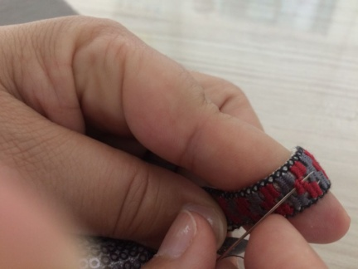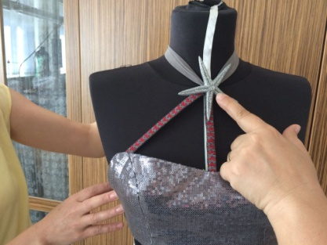
Doing embroidery for the straps Fixing shoulder straps
( Using local purl )
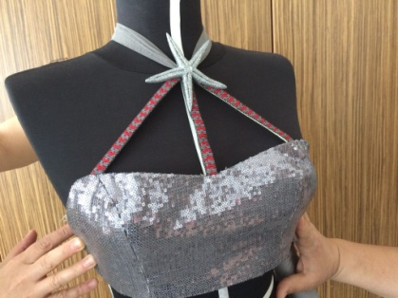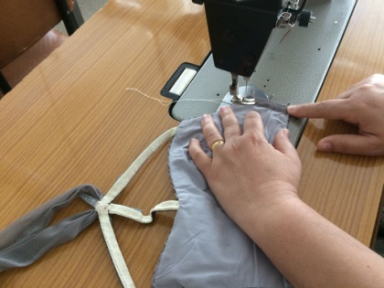
Placing the star figure Sewing the side seams
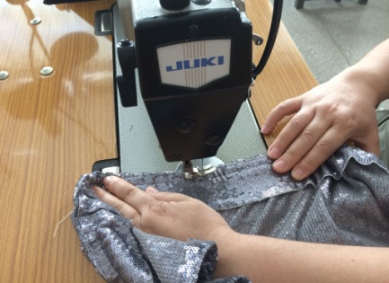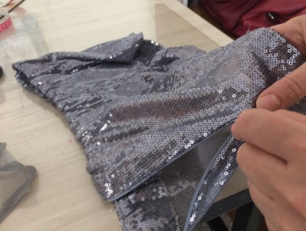
Sewing the rubber Sewing the zipper

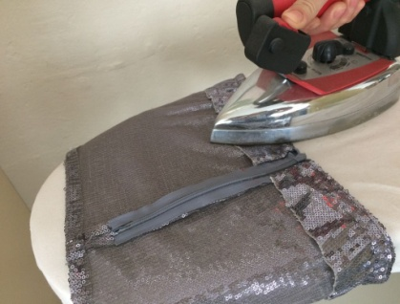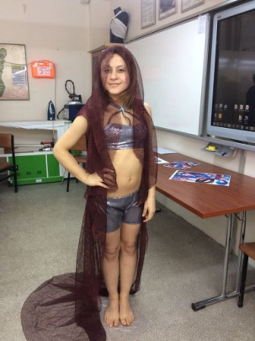
Doing the last ironing

