Worksheet: overglaze screen-printing
Materials and tools:
Printing patterns, scizzors, overglaze items
Introduction:
Screen- printing is decorative technique used to apply ceramic colors on the glost fired products. Silk screen printing is the application of ceramic colors by screening through a mesh onto a special paper with a layer which, after soaking, will allow color to be released and transferred to the product.
Instructions: work with printing patterns/stickers
- Choose the pattern – motifs
- Cut them out
- Choose the item – suitable size and shape
- Soak it with water
- Apply it on the surface with the colours up and remove the transfer paper carefully
- Smooth and dry
- Wash the product an hour later (after drying the stickers)
- Fire at 800 °C
Important notes:
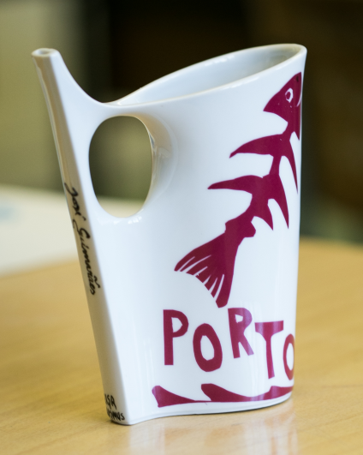
The stickers must not be applied one after another, with right side down or leave air bubbles under stickers.
