Worksheet: underglaze cobalt decoration
Materials and tools: Cobalt colour, brushes, sketches, biscuit-fired clay (a vase, plate etc.)
Introductions:
Cobalt oxide is the ceramic colour which is applied either underglaze on the biscuit- fired clay and after fixation with re-firing, glaze and glost fire at 1400°C or first-fired clay and glost fire at 1200-1400°C. After glost firing the typical cobalt-blue colour shows through the glaze. Lines are blured with soft contours.
Instructions
- Cobalt preparation: the solid colour is watered down with the solvent and carefully mixed on the glass palette.
- Application can be done with:
  - Classical brushes - various "flat" strokes or prints, shading
  - Calligraphy brushes - weak strokes, lines, shading
  - Sponge - application of surfaces, or prints of "structures"
  - Strings, curtains ...
- It is necessary to re-fire the clay with the cobalt paint before glazing because it can be smudged.

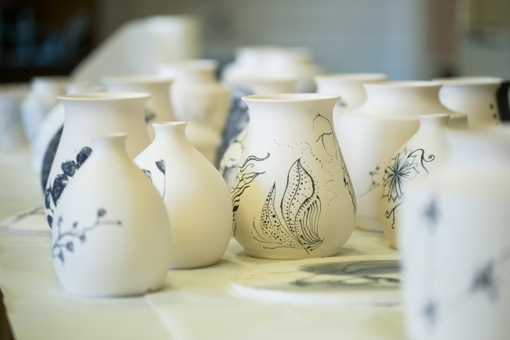
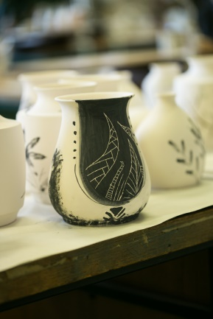
After glazing and glost firing,
