Skirt
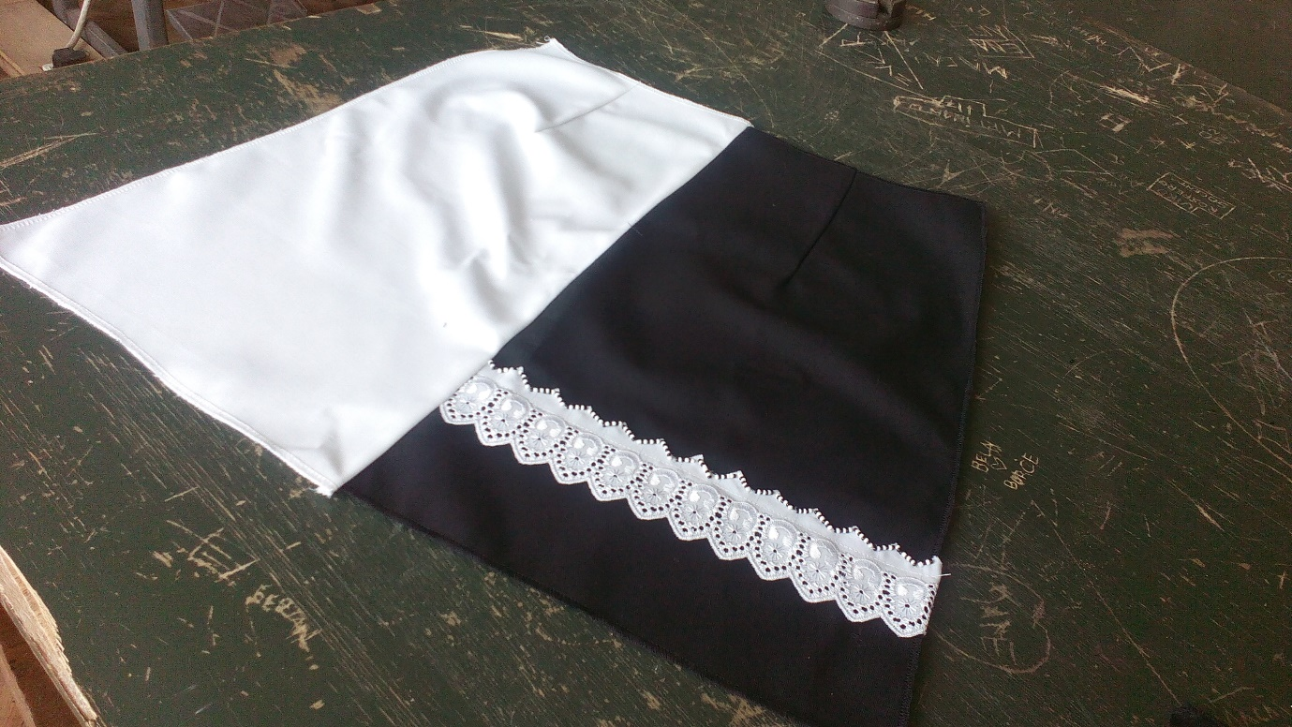

1.Sketch and model analysis
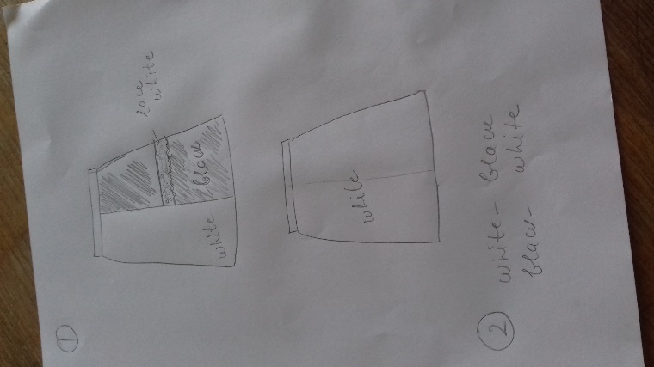
2. Preparation and structural modeling
Body height =164 cm

Bust = 100 cm
Waist = 70 cm
Hip= 98 cm
S-K = hip height

K-K₁=1/2 bust
К2= ½(K-K₁)
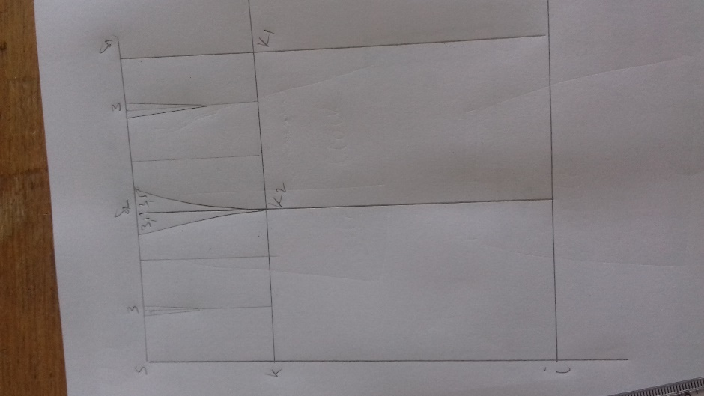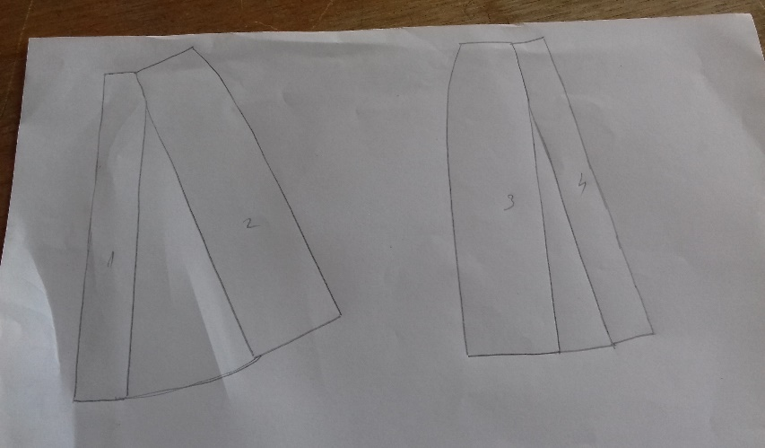

3. Manufacture
Materials required: basic materials (twill), sewing thread, lacy ribbon, beads, zippers, button.
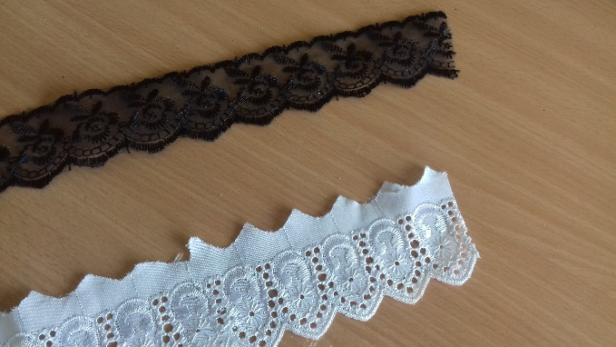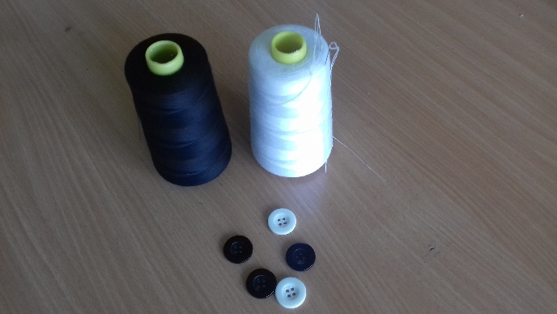
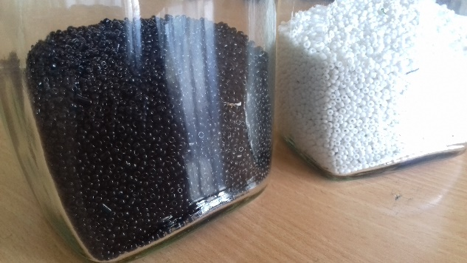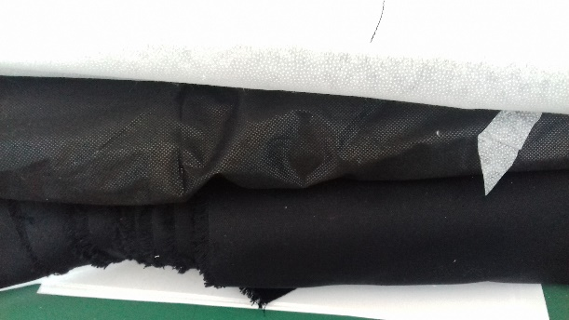

Necessary funds: sewing machine, overlocking, iron

